May 21, 2024

Nicole Singh

Climate Protection Manager

Oregon Department of Environmental Quality

Subject: Written Comment on 2024 Climate Protection Program Restoration

Rulemaking Advisory Committee Meeting #2

My name is Dr. Pat DeLaquil, and I am an energy systems modeler and climate policy analyst. I am submitting these comments on behalf of MCAT (Mobilizing Climate Action Together), which is a community of volunteers working on advancing a healthy climate and a green economy for future generations.

MCAT has worked to develop a strong Climate Protection Program in Oregon since before DEQ’s original 18-month rulemaking process, in which several members participated, along with industry and other environmental and social equity stakeholders, and the thousands of Oregonians who submitted supporting comments to DEQ. We are encouraged by DEQ’s stated goals to restore the Climate Protection Plan with enforceable and declining limits on fossil fuels beginning in 2025 with a comparable scope and emissions reduction ambitions as original CPP. We have the following comments relative to the discussion at the 2nd RAC meeting.

## Baseline Cap

The value of the baseline (or initial year) emissions cap is one of the most critical adjustments required by the delay in implementing the CPP. The 2017 to 2023 data, as provided by DEQ in Table 1 of the 2025 Base Cap Adjustment section of the Emissions Cap Rulemaking Brief, shows current emissions below the original 2025 target. This is a clear indication that the 2017-2019 period was not a good predictor for the start of the 2022-2024 period, and that the initial Cap was too high. This can be corrected as part of this rulemaking.

This most recent DEQ data indicates that maintaining the original CPP cap for 2025 (of 25.8 MMt) as the baseline for the revived program is both appropriate and manageable for the covered entities, although emission reductions were not the same for each of the covered sectors. Indeed, the fuel supply sector is trending down, largely due to the effectiveness of the Clean Fuels Program, rising demand for biodiesel, improvements in vehicle efficiency and vehicle electrification.

## 2025 Check-in Validation Period

Given the delays in the original program, DEQ should make 2025 a check-in validation year to review the actual data from the 2022-2024 period, and to possibly make market share adjustments between covered sectors. Such a Check-in period would also allow DEQ to consider credit for covered entities that have taken clear actions to comply with the CPP, as discussed in the next point. This check-in validation process would also determine which measurable and verifiable emission reductions should be considered for credits. For example, reductions made thru the Clean Fuel Program should not also qualify for CPP credit.

The first formal compliance period would still be 2025-2027, but the check-in validation period would give a clearer understanding of where additional efforts may be needed.

## Crediting Early Actions

We are concerned by the consideration that DEQ has given to idea of crediting entities for early actions taken under the now invalidated CPP. Given that we wouldn’t be in this situation if the fuel suppliers and gas utilities hadn’t raised the lawsuit in the first place. ***DEQ should not reward any entity that was a party to the lawsuit!***

In addition, **DEQ should not consider any additional credits until the check-in validation period** for the following reasons:

* Many other factors contributed to the reductions in overall emissions, including in vehicle efficiency gains and electrification, and changing habits, and
* Criteria are needed to identify biofuel sales that qualify for CPP purposes.

Indeed, the example provided by DEQ in Table 1 of the CPP Base Cap Distribution section of the Emissions Cap Rulemaking Brief was quite disturbing in the implication that 4 MMt of allowances (the “extra” decrease in emissions) would be fully allocated based on sales only the 1MMt of biodiesel sales (with assumed CI=1). Only measurable and verifiable emission reductions should be considered for credits, which is one reason that we continue to recommend that **DEQ consider 2025 a Check-In Validation Period**, whereby DEQ reviews the 2022 to 2024 actual emission data, and compares that to the proportional market share of the **new baseline emission cap**, and provide bonus allowances only for direct actions, like biofuels delivery specifically for CPP credit. Referring to DEQ’s Table 1 referenced above, assuming both Fuel Suppliers had equal market shares and that their reported biofuel deliveries were specifically for the CPP, then Fuel Supplier A would get 250,000 Mt of bonus allowances and Fuel Supplier B would get 750,000 Mt of bonus allowances.

## Community Climate Investments

Some concerns were expressed that Community Climate Investments (CCIs) are uncertain reductions that take place in the near future, while for example Renewable Thermal Credits (RTCs) are immediate and verified emission reductions. The energy efficiency and fuel switching measures expected to be implemented with CCI fund support all have proven measurement and validation protocols, just like RTCs. However, there is a fundamental timing difference in these two compliance options, but that does not mean CCIs are less effective than RTCs. Indeed, the opposite is true. Over the implementation time period for the Climate Protection Plan, CCIs will deliver 2.5 times more cumulative emission reductions and cost only 45% as much as purchasing RTCs.

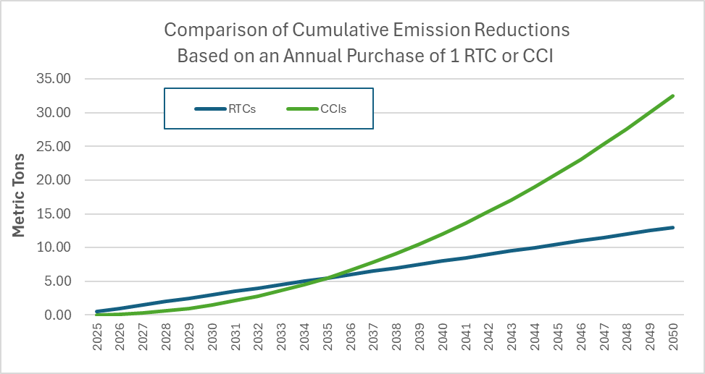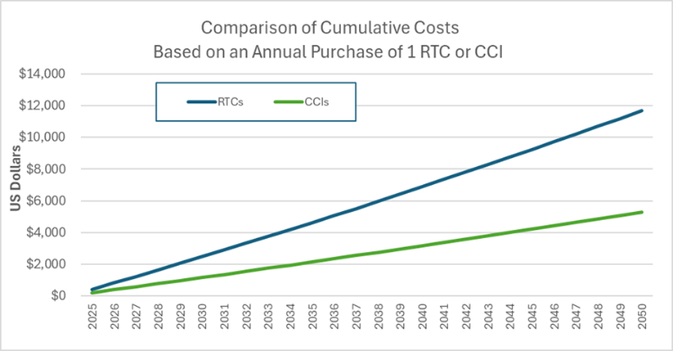

Details of these calculation are summarized in the Annex to these comments. In summary, the calculation compares the cost and actual emission reductions resulting from an annual purchase of 1 RTC versus 1 CCI from 2025 thru 2050. The calculation includes an assumed 50% carbon intensity for RTCs, and cost data from the Tranche 1 and 2 cost categories in the NWN IRP. For CCIs, the most recent estimate for the social cost of carbon in 2025 of $190/Mt was used, and the average time that projects return 1 Mt of cumulative emission reductions was estimated at 10 years based on a likely mix of projects and their overall effectiveness.

***This analysis shows conclusively that the CCI program, as originally conceived, provides significant better overall results for dramatically lower cost.*** In addition, the scope and nature of the program are also best suited to directly benefitting Oregonians, and to achieving the program’s equity-based goals.

Thank you for the opportunity to comment on this important matter.

**MCAT Steering Committee**

Brett Baylor, Rick Brown, Linda Craig, Pat DeLaquil, Dan Frye, Debby Garman, KB Mercer, Michael Mitton, Rich Peppers, Rand Schenck, Jane Stackhouse, Joe Stenger and Catherine Thomasson

# Annex on CCI versus RTC Calculations

This calculation compares the cost and actual emissions resulting from an annual purchase of 1 RTC versus 1 CCI from 2025 thru 2050. Because of limitations in DEQs authority, RTCs under the CPP are given a 0% carbon intensity, but in reality, such biofuel credits have a carbon intensity of 30% to more than 60% of fossil fuels. This calculation accounts for that reality. Similarly, the calculation also accounts for the average time that CCI projects will return 1 Mt of cumulative emission reductions. Data inputs and assumptions are summarized below:

* RTC costs were based on the NWN IRP data for Tranche 1 and 2 RTC cost categories, and vary linearly from the 2025 to the 2050 values shown in the table to the right.
* For this example, the RTC carbon intensity was assumed to average at 50%, so we are comparing actual emission reduction and costs.
* The average time that CCI projects will return 1 Mt of cumulative emission reductions was estimated at 10 years based on a likely mix of projects and their overall effectiveness.

The figure below provides a comparison of the cumulative metric tons of actual emission reductions resulting from an annual purchase of 1 RTC versus 1 CCI from 2025 thru 2050. It shows RTC have a small early edge, but after 2035 the CCI reductions begin to significantly exceed those from RTCs, such that cumulative emission reductions from CCIs are 2.5 times that from RTCs.



The next figure below shows the cumulative cost for the annual purchase of 1 RTC versus 1 CCI. Given that CCI are both less costly and more effective over time, the cumulative cost of CCIs is significantly lower than RTC over the entire time horizon.

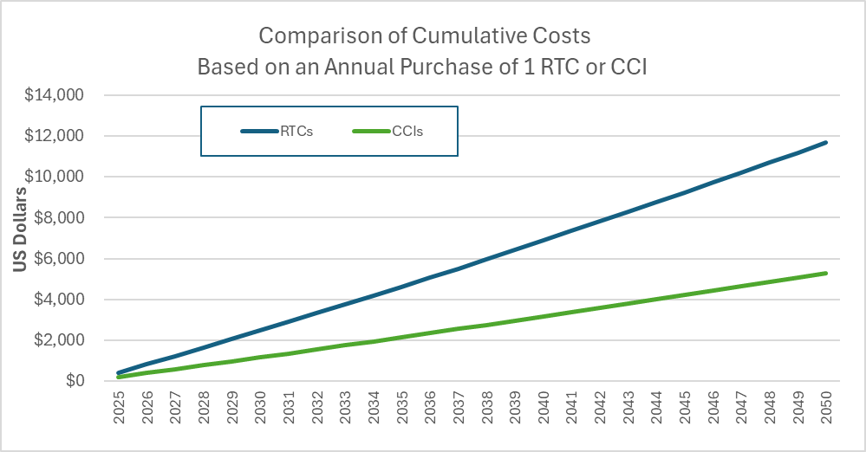

The calculation was done on an annual basis, and a summary of the 5-year interval values is provided in the table below, which is based on the inputs provided in the table at the start of this Annex.

